**LOW LEVEL DESIGN DOCUMENT**

**UBER Eats**

**Prepared by** : Bhavana Prabhakar

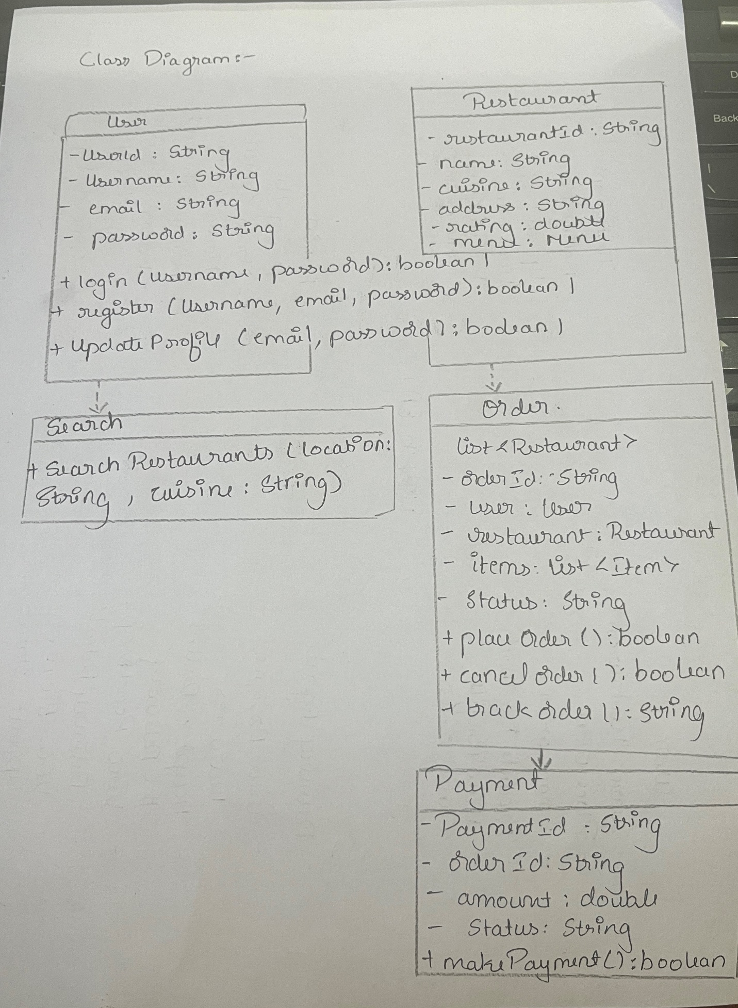

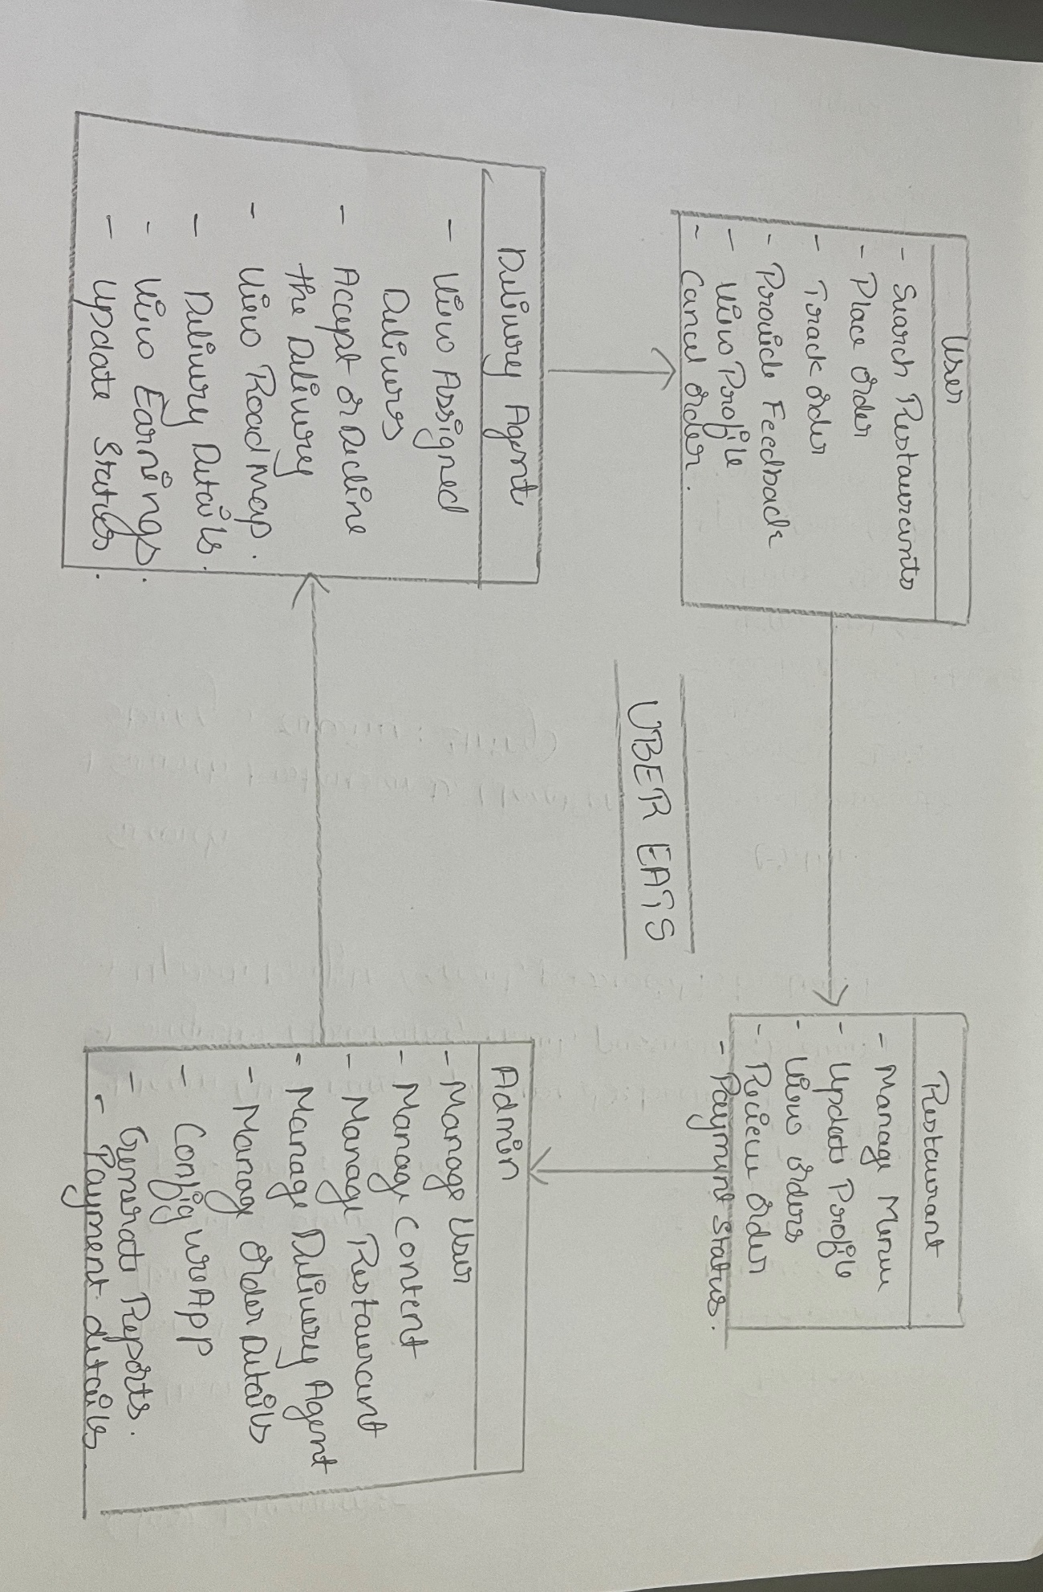Sequence diagram

